# **Historical Events: The Ukrainian Famine**

# **Name:**

*Instructions:* Read the event(s) assigned to your group and answer the questions that follow. Be prepared to share your answers with the class.

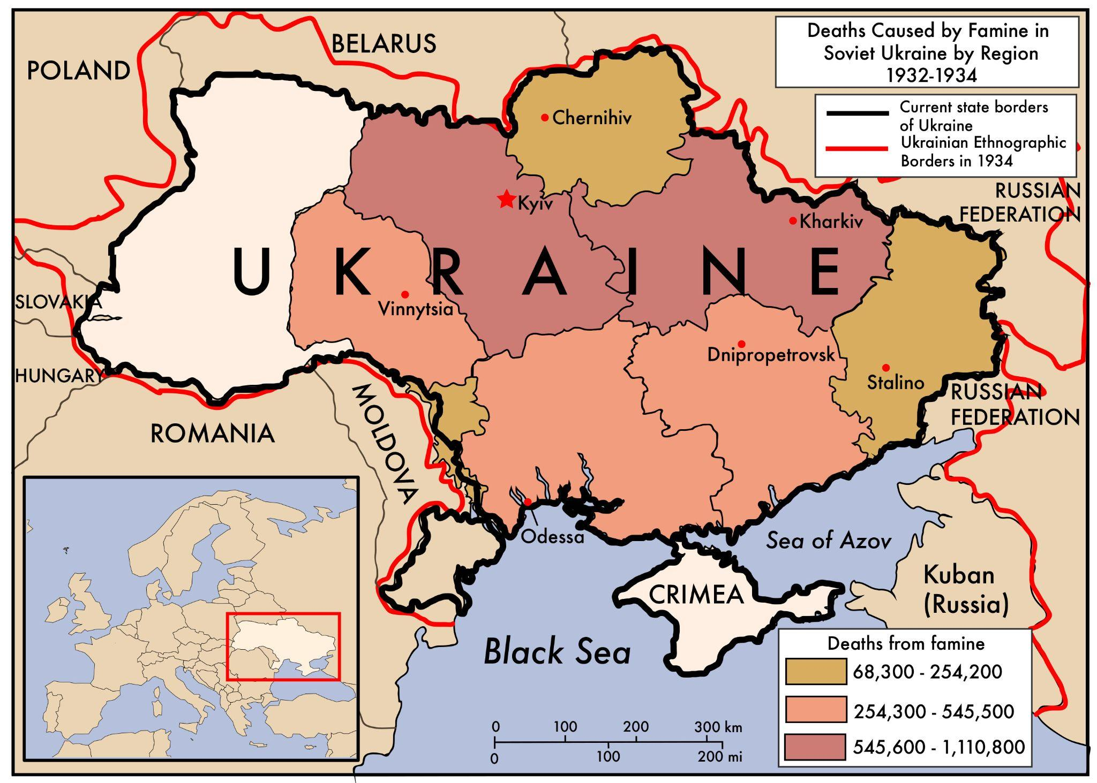

***Note on Disturbing Content***

*This reading contains content that may be upsetting for readers. It describes physical and psychological violence, and might be particularly intense for students with a personal connection to the topic. It is important to be sensitive to your classmates and the ways in which this might be a difficult topic to study.*

Russia and Ukraine have been closely linked politically and economically since the eighteenth century, when the Russian Empire established control over much of what is today Ukraine. During the Soviet era (1917-1991), Ukraine was home to much of the Soviet Union’s agriculture and industry.

In 1928, the leader of the Soviet Union—Josef Stalin—imposed a Five-Year Plan designed to industrialize the struggling Soviet economy. Stalin believed that the Soviet Union had to industrialize at all costs in order to compete against the threat of the capitalist countries of Europe, the United States, and Japan.

The plan included ending small-scale farming and forcing the farmers, known as *kulaks*, to work on large-scale farms. This process was known as “collectivization.” When Ukrainian *kulaks* were told they would have to give up their land to the Soviet state and grow what they were told, they resisted. In response, Stalin announced in 1929 his intention to “liquidate [eliminate] the *kulaks*.” Hundreds of thousands were deported to forced labor camps, called *Gulags*, in Siberia, the expansive northern Russian state known for its cold temperatures and severe winters.

The changes Stalin made to the agricultural system led to poor harvests and ultimately food shortages and famine. This was true in other parts of the Soviet Union, but Stalin saw the shortages in Ukraine as acts of sabotage by disloyal Ukrainians. The truth was that the policies of “collectivization,” not sabotage, had created the vast shortages and famine. Because Stalin saw the failures as a result of plots by Ukrainian groups resisting Soviet rule, he escalated the Soviet crackdown in Ukraine, worsening the famine. All grain was shipped to Russia, leaving none for the Ukrainians who grew it. Families resorted to eating field mice and even grass. Many were killed or deported, and millions were left by the Soviet government to starve to death. Between three and five million Ukrainians died of starvation in 1932 and 1933. The famine is often referred to as the Holodomor, which means “to kill by starvation” in Ukrainian.

**Questions**

1. Were the Soviet Union’s actions in Ukraine a genocide? Give at least two reasons from the text to support your view.

2. What standards from Article II of the Genocide Convention apply to determine if this event was a genocide?

3. What additional information would you like to have about the famine in Ukraine?